**Documentation:**

* This document.
* GitHub repository (https://github.com/LargerSnowdevil/HIT339-Assignment-2).
* Database Diagrams (Last page of this document or in Git Repos).

**Tables Needed:**

* Coaches:
  + Username
  + Name.
  + Age.
  + A biography.
* Schedules (events):
  + Event name.
  + Date.
  + Location.
  + Who is running it (Coach).
  + Members enrolled.
* Memberships:
  + Username.
  + Email.
  + Password.

**Pages Needed:**

* View schedule.
* View coach profile.
* Create accounts.
* Add a member to a scheduled item.
* Edit a coach account.
* Create schedule.
* Schedule Details.
  + View members in schedule.
* Add coach to schedule.
* View all members.

**Requirements:**

Members need to:

* View the schedules with who is coaching them at any time from the website.
* View coach profiles from a list, and from the schedule details.
* Create an account so that we can email them of upcoming specials.
* Enrol in a scheduled item before the scheduled date once they have logged in.

Members should not see anything else!

-------------------------------------------------------------------------------------------------------------------------

Coaches need to be able to log in and:

* Create/Edit a profile with a brief biography.
* See their upcoming schedules.
* See their enrolled members for each schedule.

Coaches should not see anything else!

-------------------------------------------------------------------------------------------------------------------------

Admin needs to be able to log in and:

* Create schedules with event-name, date, location, and coach.
* Match coaches with schedules.
* View all membership in a list.

Admin should see the lot.

Database Diagram without Identity Tables:

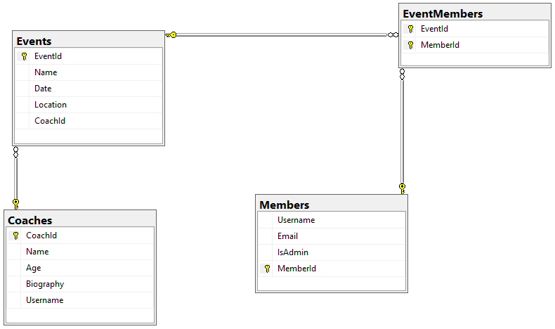

Database Diagram with Identity Tables:

